MQTT Documentation
- Match command_id in Examples
In many JSON examples, the command_id sent in the Request (e.g., "req-001") differs from the one shown in the Response (e.g., "abcd1432"). Please ensure the request and response examples use the exact same command_id.
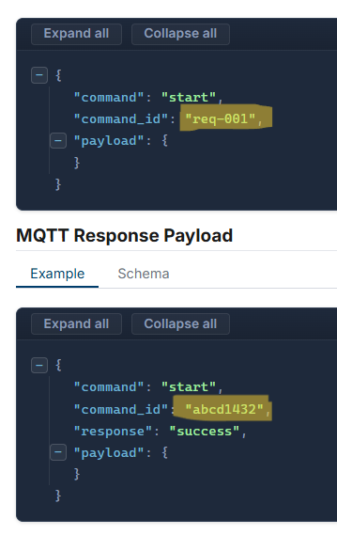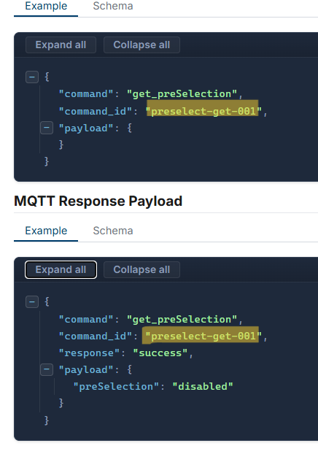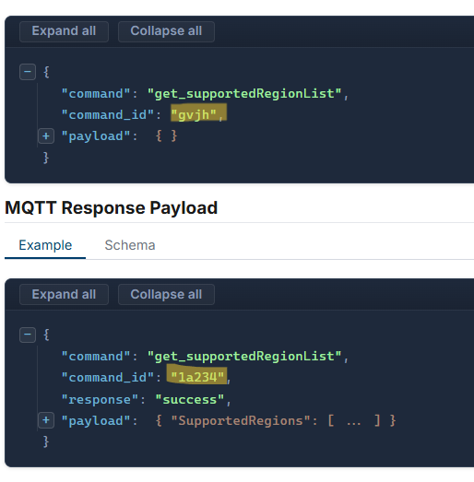
- Standardize JSON Casing
The API standard is camelCase (e.g., macAddress). However, a few commands drift into snake_case (e.g., debug_level, background_processing_interval_seconds) and some ALL CAPS (e.g., IPV4, IPV6) vs others no caps (e.g., Gpio, Gpo). Please standardize these to camelCase and CAPS where needed to prevent developers' auto-generated code from breaking and to improve readability.
- Page Headers & Titles
A few page headers combine words or drop camelCase, making them a bit hard to read.
Add spaces to titles like:
- "Get Cablelosscompensation" ➔ "Get Cable Loss Compensation"
- "Get Appled" / "Get Stackled" ➔ "Get App LED" / "Get Stack LED"
- "Get Esimconfig" ➔ "Get eSIM Config"
- "Get Availablewifinetworks" ➔ "Get Available Wi-Fi Networks"

- Clean Up the Left-Hand Navigation Menu
Currently, the left-side navigation sidebar uses the raw code titles (like "Get Cablelosscompensation"). To make the documentation much easier to skim, let's update the sidebar labels to be clean, human-readable names (e.g., "Cable Loss Compensation", "Network Interfaces", "App LED", etc -> see image below)
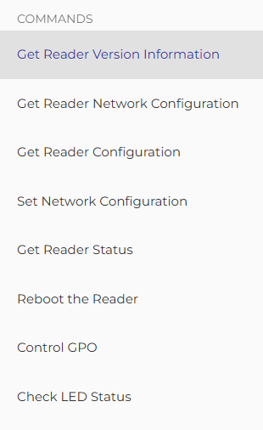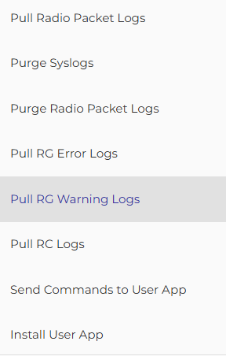

- Catch Quick Typos
A quick global search-and-replace for:
- environement ➔ environment
- retrive ➔ retrieve
- certficate ➔ certificate
- accesss ➔ accesses

REST APIs
1. Improve Text Contrast in Dark Mode
When viewing the documentation in dark mode, some of the text blends into the background and becomes very hard to read. Can we switch to a lighter, high-contrast color
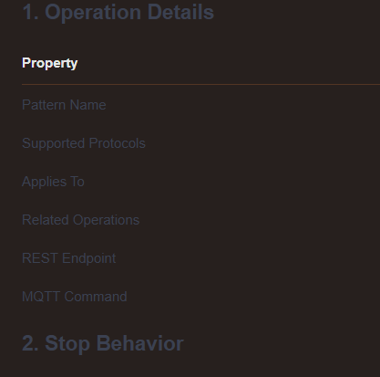 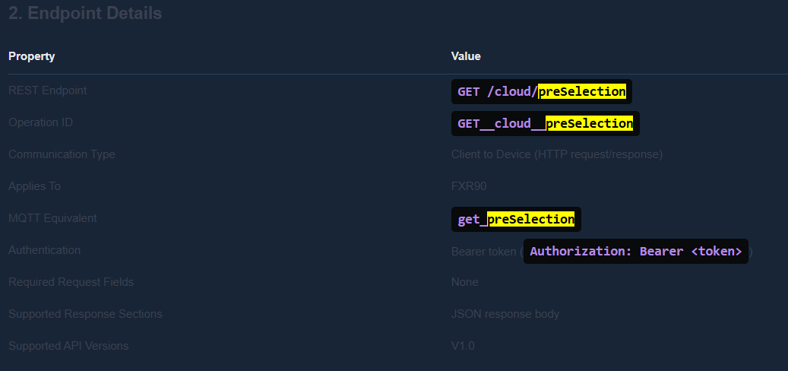
2. Reader should be FXR90 instead of FX90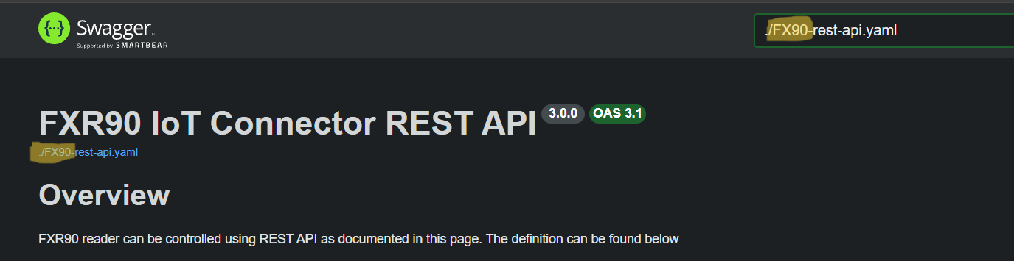

3. Standardize Operation IDs & JSON Casing
- Operation IDs: The Swagger operationId fields are currently a mix of formats, which will make auto-generated developer SDKs look messy. Let's standardize them all to strict camelCase.
  - Examples: localrestlogin ➔ localRestLogin, setRevertbackos ➔ revertBackOS, GET__cloud__preSelection ➔ getPreSelection.
- JSON Casing: In the schema for /cloud/supportedStandardList, the key is listed as channeldata (lowercase 'd'), but everywhere else in the API it is channelData. Let's ensure this is perfectly consistent.
4. Grammar
- Verb Tenses: A search-and-replace error seems to have affected most PUT endpoint descriptions. Update phrases like "...is used to enables or disables", "...is used to updates", and "...is used to restarts" to their proper grammar ("enable or disable", "update", "restart").
- Remove Internal Notes? Almost every endpoint description includes the bullet point: "Keep REST behavior aligned with the documented reader workflow." .. (is this internal note or expected to have in the documentation?)
